实验名称 | 生产者消费者问题
学号 | 1120141831 | 姓名 | 朴泉宇
一、实验目的
在Windows以及Linux平台下实现多进程经典问题——生产者消费者问题，掌握在两个平台下进程之间的通信方法。
二、实验内容
- 分别编写Windows下的多进程代码、Linux下的多进程代码
- 在Windows下编译运行程序，得到相应结果
- 在Linux下编译运行程序，得到相应结果
- 对比Windows下以及Linux下的进程之间通信方式的区别
三、实验环境及配置方法
- 利用Visual Studio编写Windows下的代码，并编译运行
- 利用Notepad++编写Linux下的代码，在Ubuntu中调用g++编译，运行
四、实验方法和实验步骤（程序设计与实现）
- 编写Windows下的多进程代码
- 思路
- 在CreateProcess()的时候，借鉴Linux的fork()的思路，将主程序复制成多份子程序，在创建子程序的时候将递增的程序序列号（Serial No.，即nCloneID）分配给每个子程序。这个序列号用于判断进入Producer分支或者Consumer分支。
- 进程间的通信采用共享内存及文件映射的方式。父进程创建共享内存及文件映射，还有对应的信号量，供子进程使用、维护。
- 缓冲区采用循环队列形式。
- Producer子进程获取共享内存和文件映射的句柄，用于操作缓冲区；也获取信号量的句柄，用于限制其他进程缓冲区的使用权。生产特定字母（P、Q、Y），放入缓冲区，并释放缓冲区的使用权。
- Consumer子进程获取共享内存和文件映射的句柄，用于操作缓冲区；也获取信号量句柄，用于限制其他进程对缓冲区的使用。消费已在缓冲区中的字母（按照先生产先消费原则），并释放缓冲区的使用权。
- 父进程等待所有Producer以及Consumer进程都完成各自的生产和消费任务。关闭相关句柄，结束程序。
- #define及数据结构定义解释
- #include <stdio.h>
- #include <Windows.h>
- #include <time.h>
- #include <tchar.h>

- #define ID_MAIN 0 //Main函数的序列号
- #define ID_PRODUCER_START 1 //Producer进程开始序列号
- #define ID_PRODUCER_ENDS 3 //Producer进程结束序列号
- #define ID_CONSUMER_START 4 //Consumer进程开始序列号
- #define ID_CONSUMER_ENDS 7 //Consumer进程结束序列号

- #define PRODUCER_WORKS_TIMES 4 //每一个Producer生产4次
- #define CONSUMER_WORKS_TIMES 3 //每一个Consumer消费3次

- #define BUFFER_SIZE 4 //缓冲区大小
- #define PROCESS_NUM 7 //子进程总数量 用于创建子进程列表
- TCHAR sharedMemName[] = TEXT("Global\\MyFileMappingObject"); //共享内存映射文件名

- /*The Buffer, use to cache.*/
- struct myBuffer
- {
- char Buffer[BUFFER_SIZE + 1];
- int head;
- int tail;
- int isEmpty;
- };

- /*The sharedMemory used to realize Buffer.*/
- struct sharedMem
- {
- struct myBuffer bufferData;
- int index;
- };

- /*File Mapping HANDLE.*/
- static HANDLE hMapping;

- /*The HANDLE array of Child Process.*/
- static HANDLE hChildProcess[PROCESS_NUM + 1];
- 函数定义解释
- 随机数函数
- /*Get the number between 0 - 3000, used to stop between 0 - 3 seconds.*/
- int getRandomInt()
- {
- int randnum;
- //srand((unsigned)(GetCurrentProcessId() + time(NULL)));
- randnum = rand() % 3001;

- return randnum;
- }
- 随机获取字母函数
- /*Get the Letter P or Q or Y, is the product.*/
- char getRandomLetter()
- {
- char letterMap[4] = { 'P','Q','Y','\0' };
- int randNum;
- //srand((unsigned)(GetCurrentProcessId() + time(NULL)));
- randNum = rand() % 3;

- return letterMap[randNum];
- }
- 创建共享内存函数
- /*Make shared memory.*/
- HANDLE MakeSharedMem()
- {
- /*Make view of file.*/
- HANDLE fMapping = CreateFileMapping(INVALID_HANDLE_VALUE, NULL, PAGE_READWRITE, 0, sizeof(struct sharedMem), sharedMemName);
- if (fMapping != INVALID_HANDLE_VALUE)
- {
- LPVOID pData = MapViewOfFile(fMapping, FILE_MAP_ALL_ACCESS, 0, 0, 0);
- if (pData != NULL)
- {
- memset(pData, 0, sizeof(struct sharedMem));
- }
- UnmapViewOfFile(pData);
- }

- return fMapping;
- }
- 创建子进程函数
- /*Clone the Process.*/
- void cloneChildProcess(int nCloneID)
- {
- TCHAR szFilename[MAX_PATH];
- TCHAR szCmdLine[MAX_PATH];
- char tempFilename[MAX_PATH];
- char tempCmdLine[MAX_PATH];
- STARTUPINFO si;
- PROCESS_INFORMATION pi;

- GetModuleFileName(NULL, szFilename, MAX_PATH);
- TCHAR_to_char(szFilename, tempFilename);
- sprintf(tempCmdLine, "\"%s\" %d", tempFilename, nCloneID); //给子进程传入参数
- char_to_TCHAR(tempCmdLine, szCmdLine);
- memset(&si, 0, sizeof(si));
- si.cb = sizeof(si);

- /*Create Child Process.*/
- BOOL bCreateOK = CreateProcess(
- szFilename,
- szCmdLine,
- NULL,
- NULL,
- FALSE,
- 0,
- NULL,
- NULL,
- &si,
- &pi
- );
- hChildProcess[nCloneID] = pi.hProcess; //向子进程列表中对应子进程填充pi.hProcess信息

- return;
- }
- THCAR转char函数
- /*Change TCHAR to char*/
- void TCHAR_to_char(const TCHAR * tchar, char * _char)
- {
- int iLength;

- iLength = WideCharToMultiByte(CP_ACP, 0, tchar, -1, NULL, 0, NULL, NULL); //Get the length.
- WideCharToMultiByte(CP_ACP, 0, tchar, -1, _char, iLength, NULL, NULL); //Give tchar value to _char.
- }
- char转TCAHR函数
- /*Change char to TCHAR*/
- void char_to_TCHAR(const char * _char, TCHAR * tchar)
- {
- int iLength;

- iLength = MultiByteToWideChar(CP_ACP, 0, _char, strlen(_char) + 1, NULL, 0);
- MultiByteToWideChar(CP_ACP, 0, _char, strlen(_char) + 1, tchar, iLength);
- }
- main函数解释
- 信号量句柄声明以及打印进程信息（进程PID以及序列号nCloneID）
- int nClone = ID_MAIN;
- SYSTEMTIME nowTime;
- HANDLE semEmpty; //声明取空缓冲区，同步信号量句柄
- HANDLE semFull; //声明取有产品的缓冲区，同步信号量句柄
- HANDLE semMutex; //声明对整个缓冲区的互斥信号量

- /*Give the parameter to nClone.*/
- if (argc > 1)
- {
- sscanf(argv[1], "%d", &nClone);
- }

- /*Print Process ID and Serial Number.*/
- printf("Process ID: %d, Serial No: %d.\n", GetCurrentProcessId(), nClone);
- 父进程：创建内存共享，创建文件映射，初始化缓冲区，创建信号量，创建生产者、消费者子进程，等待子进程结束。
- if (nClone == ID_MAIN)
- {
- printf("Main Process starts.\n");

- /*Start the shared memory.*/
- hMapping = MakeSharedMem();
- /*Mapping the view*/
- HANDLE hFileMapping = OpenFileMapping(FILE_MAP_ALL_ACCESS, FALSE, sharedMemName);
- LPVOID pFile = MapViewOfFile(hFileMapping, FILE_MAP_ALL_ACCESS, 0, 0, 0);
- if (pFile == NULL)
- {
- printf("OpenFileMapping Error!\n");

- return -1;
- }
- else
- {
- struct sharedMem * SHM = (struct sharedMem *)pFile;
- memset(SHM->bufferData.Buffer, '-', sizeof(SHM->bufferData.Buffer));
- SHM->bufferData.Buffer[BUFFER_SIZE] = '\0';
- SHM->bufferData.head = 0;
- SHM->bufferData.tail = 0;
- SHM->index = 0;
- semEmpty = CreateSemaphore(NULL, BUFFER_SIZE, BUFFER_SIZE, TEXT("SEM_EMPTY"));
- semFull = CreateSemaphore(NULL, 0, BUFFER_SIZE, TEXT("SEM_FULL"));
- semMutex = CreateMutex(NULL, FALSE, TEXT("SEM_MUTEX"));
- UnmapViewOfFile(pFile);
- pFile = NULL;
- }
- CloseHandle(hFileMapping);

- /*Clone the Child Process.*/
- int childprocessNum = 1;
- for (childprocessNum = 1;childprocessNum <= PROCESS_NUM;childprocessNum++)
- {
- cloneChildProcess(childprocessNum);
- }

- /*Wait child process ends.*/
- int i;
- for (i = 1; i <= PROCESS_NUM;i++)
- {
- WaitForSingleObject(hChildProcess[i], INFINITE);
- CloseHandle(hChildProcess[i]);
- }
- printf("Main Process ends.\n");
- }
- Producer进程：获取内存共享及内存共享的句柄，获取信号量句柄，每个生产者进程循环PRODUCER_WORKS_TIMES生产产品，打印时间、缓冲区、生产信息。生产完毕后结束进程。
- /*The Producer Process.*/
- if (nClone >= ID_PRODUCER_START&&nClone <= ID_PRODUCER_ENDS)
- {
- printf("Producer No.%d starts.\n", nClone - ID_MAIN);

- /*Mapping the view.*/
- HANDLE hFileMapping = OpenFileMapping(FILE_MAP_ALL_ACCESS, FALSE, sharedMemName);
- LPVOID pFile = MapViewOfFile(hFileMapping, FILE_MAP_ALL_ACCESS, 0, 0, 0);
- if (pFile == NULL)
- {
- printf("OpenFileMapping Error!\n");

- return -1;
- }
- else
- {
- struct sharedMem * SHM = (struct sharedMem*)pFile;
- semEmpty = OpenSemaphore(SEMAPHORE_ALL_ACCESS, FALSE, TEXT("SEM_EMPTY"));
- semFull = OpenSemaphore(SEMAPHORE_ALL_ACCESS, FALSE, TEXT("SEM_FULL"));
- semMutex = OpenMutex(MUTEX_ALL_ACCESS, FALSE, TEXT("SEM_MUTEX"));

- /*Start Producer Work Times.*/
- srand((unsigned)(GetCurrentProcessId() + time(NULL)));
- char productLetter;
- int i;
- for (i = 0;i < PRODUCER_WORKS_TIMES;i++)
- {
- Sleep(getRandomInt());
- WaitForSingleObject(semEmpty, INFINITE);
- WaitForSingleObject(semMutex, INFINITE);

- /*Produce*/
- productLetter = getRandomLetter();
- SHM->index++;
- SHM->bufferData.Buffer[SHM->bufferData.tail] = productLetter;
- SHM->bufferData.tail = (SHM->bufferData.tail + 1) % BUFFER_SIZE;
- SHM->bufferData.isEmpty = 0;

- /*Print the index, time, and the product.*/
- GetLocalTime(&nowTime);
- printf("[%02d]\t", SHM->index); //Print index.
- printf("%02d:%02d:%02d\t", nowTime.wHour, nowTime.wMinute, nowTime.wSecond); //Print now time.
- int j;
- for (j = 0;j < BUFFER_SIZE;j++)
- {
- printf("%c", SHM->bufferData.Buffer[j]);
- }
- printf("\tProducer No.%d produced '%c'.\n", nClone - ID_MAIN, productLetter);

- ReleaseSemaphore(semFull, 1, NULL);
- ReleaseMutex(semMutex);
- }
- UnmapViewOfFile(pFile);
- pFile = NULL;
- }
- CloseHandle(hFileMapping);
- printf("Producer No.%d ends.\n", nClone - ID_MAIN);
- }
- Consumer进程：获取内存共享及内存共享的句柄，获取信号量句柄，每个消费者进程循环CONSUMER_WORKS_TIMES 3消费产品，打印时间、缓冲区、消费信息。消费完毕后结束进程。
- /*The Consumer Process.*/
- if (nClone >= ID_CONSUMER_START&&nClone <= ID_CONSUMER_ENDS)
- {
- printf("Consumer No.%d starts.\n", nClone - ID_PRODUCER_ENDS);

- /*Mapping the view.*/
- HANDLE hFileMapping = OpenFileMapping(FILE_MAP_ALL_ACCESS, FALSE, sharedMemName);
- LPVOID pFile = MapViewOfFile(hFileMapping, FILE_MAP_ALL_ACCESS, 0, 0, 0);
- if (pFile == NULL)
- {
- printf("OpenFileMapping Error!\n");

- return -1;
- }
- else
- {
- struct sharedMem * SHM = (struct sharedMem*)pFile;
- semEmpty = OpenSemaphore(SEMAPHORE_ALL_ACCESS, FALSE, TEXT("SEM_EMPTY"));
- semFull = OpenSemaphore(SEMAPHORE_ALL_ACCESS, FALSE, TEXT("SEM_FULL"));
- semMutex = OpenMutex(MUTEX_ALL_ACCESS, FALSE, TEXT("SEM_MUTEX"));

- /*Start Consumer Work Times.*/
- srand((unsigned)(GetCurrentProcessId() + time(NULL)));
- char ConsumptionLetter;
- int i;
- for (i = 0; i < CONSUMER_WORKS_TIMES;i++)
- {
- Sleep(getRandomInt());
- WaitForSingleObject(semFull, INFINITE);
- WaitForSingleObject(semMutex, INFINITE);

- /*Consume*/
- SHM->index++;
- ConsumptionLetter = SHM->bufferData.Buffer[SHM->bufferData.head];
- SHM->bufferData.Buffer[SHM->bufferData.head] = '-'; //Set Used!
- SHM->bufferData.head = (SHM->bufferData.head + 1) % BUFFER_SIZE;
- SHM->bufferData.isEmpty = (SHM->bufferData.head == SHM->bufferData.tail);

- /*Print the index, time, and the consumption.*/
- GetLocalTime(&nowTime);
- printf("[%02d]\t", SHM->index);
- printf("%02d:%02d:%02d\t", nowTime.wHour, nowTime.wMinute, nowTime.wSecond);
- int j;
- for (j = 0;j < BUFFER_SIZE;j++)
- {
- printf("%c", SHM->bufferData.Buffer[j]);
- }
- printf("\tConsumer No.%d consumed '%c'.\n", nClone - ID_PRODUCER_ENDS, ConsumptionLetter);

- ReleaseSemaphore(semEmpty, 1, NULL);
- ReleaseMutex(semMutex);
- }
- UnmapViewOfFile(pFile);
- pFile == NULL;
- }
- CloseHandle(hFileMapping);
- printf("Consumer No.%d ends.\n", nClone - ID_PRODUCER_ENDS);
- }
- else
- {
- printf("nClone Error!\n");

- return -1;
- }
- 结束：关闭句柄，结束。
- CloseHandle(hMapping);
- hMapping == INVALID_HANDLE_VALUE;

- return 0;
- 编写Linux下的多进程代码
- 思路
- Linux的fork()的继承特性，使得无需在进程之间的关联性上像Windows一样进行命名等标记，也无需通过传入序列号来进行生产者消费者进程的控制。
- 进程间的通信同样采用共享内存的方式。父进程创建共享内存，还有对应的信号量，供子进程使用、维护。
- 缓冲区同样采用循环队列形式。
- Producer子进程获取共享内存的指针，用于操作缓冲区；信号量的控制模拟理论上的P、V操作，用于限制或释放其他进程缓冲区的使用权。生产特定字母（P、Q、Y），放入缓冲区，并释放缓冲区的使用权。
- Consumer子进程获取共享内存指针，用于操作缓冲区；信号量的控制模拟理论上的PV操作，用于限制或释放其他进程缓冲区的使用权。消费已在缓冲区中的字母（按照先生产先消费原则），并释放缓冲区的使用权。
- 父进程等待所有Producer以及Consumer进程都完成各自的生产和消费任务。解绑共享内存及信号量，结束。
- #define及数据结构定义解释
- #include <stdio.h>
- #include <time.h>
- #include <unistd.h>
- #include <stdlib.h>
- #include <sys/types.h>
- #include <sys/wait.h>
- #include <sys/time.h>
- #include <sys/ipc.h>
- #include <sys/shm.h>
- #include <sys/sem.h>

- //#define ID_MAIN 0
- //#define ID_PRODUCER_START 1
- //#define ID_PRODUCER_ENDS 3
- //#define ID_CONSUMER_START 4
- //#define ID_CONSUMER_ENDS 7
- #define ID_PRODUCER_NEED 3 //生产者数量
- #define ID_CONSUMER_NEED 4 //消费者数量

- #define PRODUCER_WORKS_TIMES 4 //每一个Producer生产4次
- #define CONSUMER_WORKS_TIMES 3 //每一个Consumer消费3次

- #define BUFFER_SIZE 4 //缓冲区大小
- //#define PROCESS_NUM 7
- #define SHM_MODE 0600

- #define SEM_EMPTY 0 //缓冲区空位同步信号量
- #define SEM_FULL 1 //缓冲区满位同步信号量
- #define SEM_MUTEX 2 //使用缓冲区互斥信号量

- /*The Buffer, use to catch.*/
- struct myBuffer
- {
- int index;
- char Buffer[BUFFER_SIZE + 1];
- int head;
- int tail;
- int isEmpty;
- };
- 函数定义解释
- P、V操作
- /*P operation*/
- void op_P(int sem_id, int sem_num)
- {
- struct sembuf TMP;
- TMP.sem_num = sem_num;
- TMP.sem_op = -1;
- TMP.sem_flg = 0;
- semop(sem_id, &TMP, 1);
- }

- /*V operation*/
- void op_V(int sem_id, int sem_num)
- {
- struct sembuf TMP;
- TMP.sem_num = sem_num;
- TMP.sem_op = 1;
- TMP.sem_flg = 0;
- semop(sem_id, &TMP, 1);
- }
- 取随机数函数
- /*Get the number between 0 - 3000000, used to stop between 0 - 3 seconds.*/
- int getRandomInt()
- {
- int randnum;
- //srand((unsigned)(getpid() + time(NULL)));
- randnum = rand() % 3000001;

- return randnum;
- }
- 取随机字母函数
- /*Get the Letter P or Q or Y, is the product.*/
- char getRandomLetter()
- {
- char letterMap[4] = { 'P','Q','Y','\0' };
- int randNum;
- //srand((unsigned)(getpid() + time(NULL)));
- randNum = rand() % 3;

- return letterMap[randNum];
- }
- main函数解释
- 父进程：信号量集的创建，共享内存的创建，初始化
- time_t nowTime;
- pid_t pid_Producer, pid_Consumer;

- int SEM_ALL_KEY = ftok("/tmp", 0x66);
- if (SEM_ALL_KEY < 0)
- {
- printf("ftok SEM_ALL_KEY Error!\n");

- return -1;
- }
- int SEM_ID = semget(SEM_ALL_KEY, 3, IPC_CREAT | 0600);
- if (SEM_ID >= 0)
- {
- printf("Main process starts.\n");
- }
- else
- {
- printf("Semaphore Create Error!\n");

- return -1;
- }
- semctl(SEM_ID, SEM_EMPTY, SETVAL, BUFFER_SIZE);
- semctl(SEM_ID, SEM_FULL, SETVAL, 0);
- semctl(SEM_ID, SEM_MUTEX, SETVAL, 1);

- int SHM_ID = shmget(IPC_PRIVATE, sizeof(struct myBuffer), SHM_MODE);
- if (SHM_ID < 0)
- {
- printf("SharedMemory Create Error!\n");

- return -1;
- }

- struct myBuffer *SHMPTR;
- SHMPTR = (struct myBuffer *)shmat(SHM_ID, 0, 0);
- if (SHMPTR == (void *)-1)
- {
- printf("shmat Error!\n");

- return -1;
- }
- SHMPTR->index = 0;
- SHMPTR->head = 0;
- SHMPTR->tail = 0;
- SHMPTR->isEmpty = 1;
- int i;
- for (i = 0;i<BUFFER_SIZE;i++)
- {
- SHMPTR->Buffer[i] = '-';
- }
- SHMPTR->Buffer[BUFFER_SIZE] = '\0';
- Producer进程：与Windows下的操作一致，仅在调用上有所区别，故不赘述。
- /*The Producer Process.*/
- int producerNum;
- for (producerNum = 0;producerNum < ID_PRODUCER_NEED; producerNum++)
- {
- pid_Producer = fork();
- if (pid_Producer<0)
- {
- printf("fork Error!\n");

- return -1;
- }

- if (pid_Producer == 0)
- {
- SHMPTR = (struct myBuffer *)shmat(SHM_ID, 0, 0);
- if (SHMPTR == (void *)-1)
- {
- printf("shmat Error!\n");

- return -1;
- }

- /*Start Producer Work Times.*/
- srand((unsigned)(getpid() + time(NULL)));
- char productLetter;
- int i;
- for (i = 0;i<PRODUCER_WORKS_TIMES;i++)
- {
- usleep(getRandomInt());
- op_P(SEM_ID, SEM_EMPTY);
- op_P(SEM_ID, SEM_MUTEX);

- /*Produce*/
- productLetter = getRandomLetter();
- SHMPTR->Buffer[SHMPTR->tail] = productLetter;
- SHMPTR->tail = (SHMPTR->tail + 1) % BUFFER_SIZE;
- SHMPTR->isEmpty = 0;
- SHMPTR->index++;

- /*Print the index, time, and the product.*/
- nowTime = time(NULL);
- printf("[%02d]\t", SHMPTR->index); //Print index.
- printf("%02d:%02d:%02d\t", localtime(&nowTime)->tm_hour, localtime(&nowTime)->tm_min, localtime(&nowTime)->tm_sec); //Print now time.
- int j;
- for (j = 0; j<BUFFER_SIZE; j++)
- {
- printf("%c", SHMPTR->Buffer[j]);
- }
- printf("\tProducer No.%d produced '%c'.\n", producerNum + 1, productLetter);

- op_V(SEM_ID, SEM_FULL);
- op_V(SEM_ID, SEM_MUTEX);
- }
- shmdt(SHMPTR);
- printf("Producer No.%d ends.\n", producerNum + 1);

- return 0;
- }
- }
- Consumer进程：与Windows下的操作一致，仅在调用上有所区别，故不赘述。
- /*The Consumer Process.*/
- int consumerNum;
- for (consumerNum = 0;consumerNum < ID_CONSUMER_NEED; consumerNum++)
- {
- pid_Consumer = fork();
- if (pid_Consumer<0)
- {
- printf("fork Error!\n");

- return -1;
- }

- if (pid_Consumer == 0)
- {
- SHMPTR = (struct myBuffer *)shmat(SHM_ID, 0, 0);
- if (SHMPTR == (void *)-1)
- {
- printf("shmat Error!\n");

- return -1;
- }

- /*Start Consumer Work Times.*/
- srand((unsigned)(getpid() + time(NULL)));
- char consumptionLetter;
- int i;
- for (i = 0;i<CONSUMER_WORKS_TIMES;i++)
- {
- usleep(getRandomInt());
- op_P(SEM_ID, SEM_FULL);
- op_P(SEM_ID, SEM_MUTEX);

- /*Consume*/
- consumptionLetter = SHMPTR->Buffer[SHMPTR->head];
- SHMPTR->Buffer[SHMPTR->head] = '-';
- SHMPTR->head = (SHMPTR->head + 1) % BUFFER_SIZE;
- SHMPTR->isEmpty = (SHMPTR->head == SHMPTR->tail);
- SHMPTR->index++;

- /*Print the index, time, and the product.*/
- nowTime = time(NULL);
- printf("[%02d]\t", SHMPTR->index); //Print index.
- printf("%02d:%02d:%02d\t", localtime(&nowTime)->tm_hour, localtime(&nowTime)->tm_min, localtime(&nowTime)->tm_sec); //Print now time.
- int j;
- for (j = 0; j<BUFFER_SIZE; j++)
- {
- printf("%c", SHMPTR->Buffer[j]);
- }
- printf("\tConsumer No.%d consumed '%c'.\n", consumerNum + 1, consumptionLetter);

- op_V(SEM_ID, SEM_EMPTY);
- op_V(SEM_ID, SEM_MUTEX);
- }
- shmdt(SHMPTR);
- printf("Consumer No.%d ends.\n", consumerNum + 1);

- return 0;
- }
- }
- 结束：等待所有子进程结束，并解绑信号量集、共享内存，结束。
- /*Main process ends.*/
- while (wait(NULL) != -1);
- shmdt(SHMPTR);
- shmctl(SHM_ID, IPC_RMID, 0);
- shmctl(SEM_ID, IPC_RMID, 0);
- printf("Main Process ends.\n");
- fflush(stdout);

- return 0;
- 实验结果和分析
- Windows下的实验结果
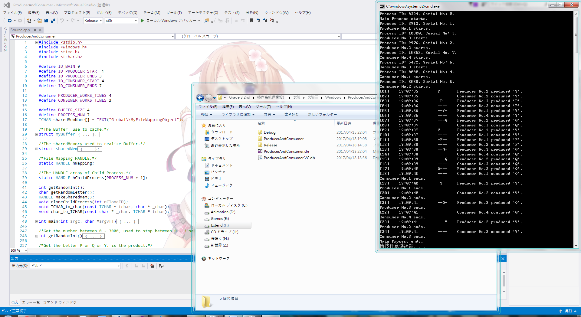

- Linux下的实验结果
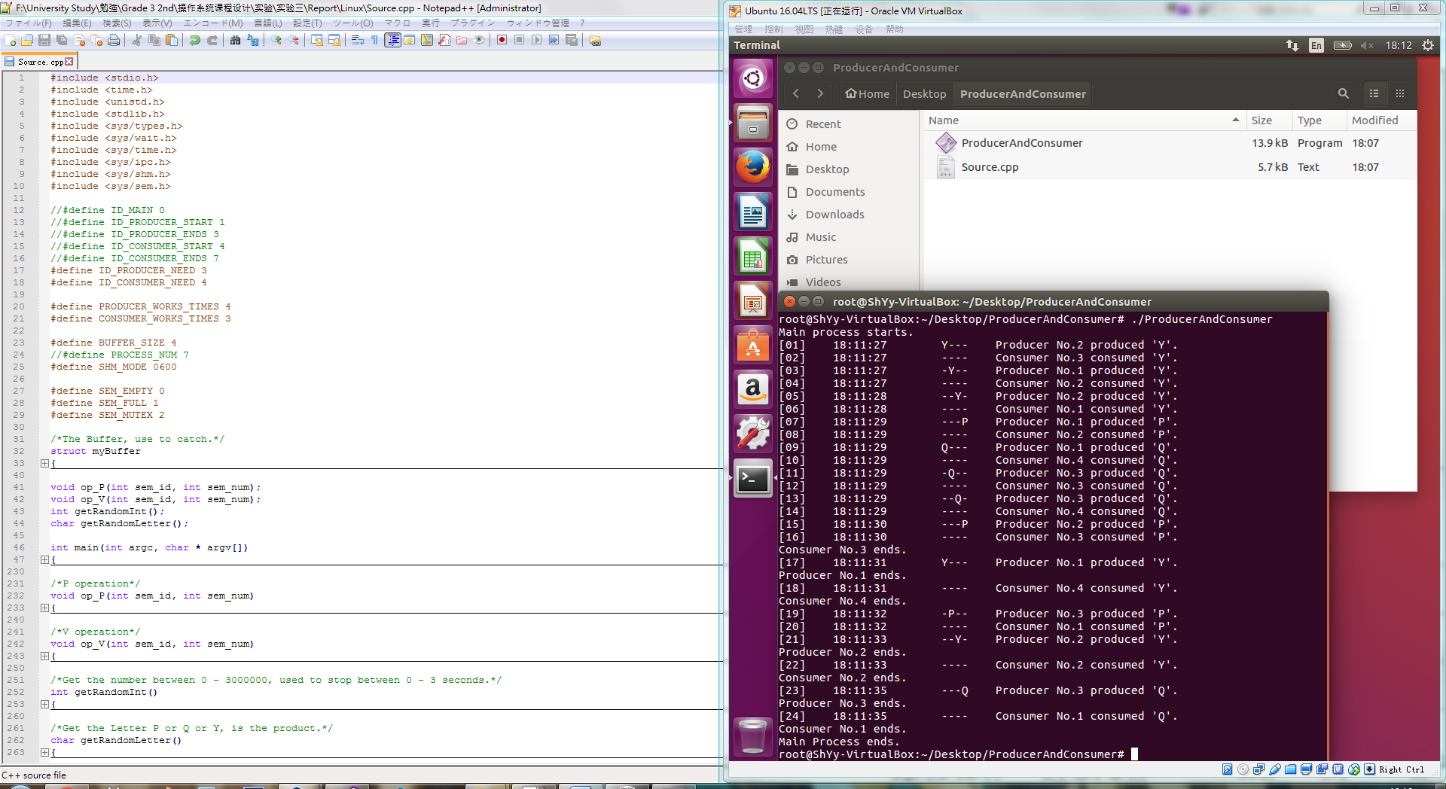
- 对比分析
Windows与Linux下的区别在于内存共享部分的调用方法以及对于信号量的操作上，相似度较高，若掌握了一个平台的实现方法，则在另一个平台下，正确调用API即可实现。
- 讨论、心得
此次实验，实现了操作系统中的经典问题。在实现这个问题的过程中，了解并掌握了Windows和Linux平台下的信号量操作方式，掌握了共享内存的进程间通信方式。
并且，在调用API的时候，通过查阅MSDN以及各方资料，阅读了一些源码，对两种平台下的进程操作方式有了更深的理解。
在修改的过程中，有同学为我指出了在Windows下句柄操作中存在的重要问题，并与我讨论、帮助我修改，让我加深了对句柄的理解，感激不尽。
学路漫漫，还需精进。

